Cointegration and ECM: NZDUSD and USDJPY
Method 27 / Engle-Granger on log closes / one-lag ECM / Alpari D1 full available history

Study setup
Logical pair: PX=NZDUSD , PY=USDJPY
Broker symbols: NZDUSD_i , USDJPY_i
Snapshot: 2026-11-03_majors_alpari_D1
Timeframe: D1
Matched window: 1999-01-05 to 2026-11-02 (UTC bar dates)
Matched level count n: 7185
Dropped unfinished last bar dated 2026-11-03 UTC after a tick-volume check against the prior complete day.
ECM lags of deltas: 1
Complete matched rows (Excel): NZDUSD-USDJPY_Coint_D1.xlsx
Complete matched rows (HTML table): NZDUSD-USDJPY_Coint_D1_data.html

Method carried forward
Engle-Granger cointegration works on log price levels, not returns. For each unordered pair, PX is the left leg and PY the right leg. Step one: OLS ln(PY) = alpha + beta * ln(PX) + e. Step two: statsmodels Engle-Granger coint test on (ln(PY), ln(PX)). Error-correction: delta ln(PY)_t = c + kappa * e_{t-1} + lagged delta ln(PY) and delta ln(PX) (one lag each) + u_t. Headline is the Engle-Granger p-value (lower = stronger evidence of a stationary spread) with kappa and beta reported alongside. Same-sample Pearson r of log returns is a side check only. beta is not an automatic lot-size hedge. This is not a trading signal.

Results (headline)
alpha: 4.520937
beta: -0.458210
Engle-Granger t: -1.319250
Engle-Granger p: 0.823852
5% critical value: -3.336981
ECM kappa: -0.000345
kappa t-stat: -0.6952
ECM R^2: 0.002570
spread std: 0.147324
Pearson r (returns): -0.133568

Conclusion
Engle-Granger for PY=USDJPY on PX=NZDUSD: beta=-0.4582, alpha=4.5209, coint_t=-1.3192, p=0.8239 (5% crit=-3.3370). ECM kappa=-0.0003 (t=-0.70). Pearson r of returns = -0.1336. beta is not a lot-size hedge. Not a trading signal.

Charts
Daily closes

Engle-Granger residual spread
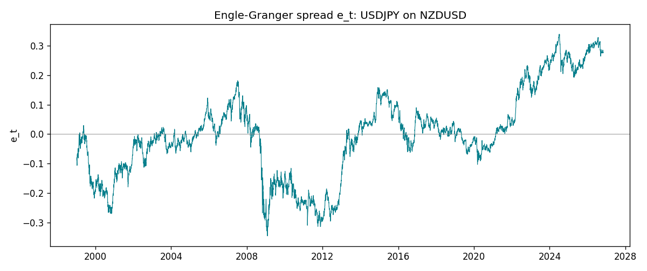
Daily log returns
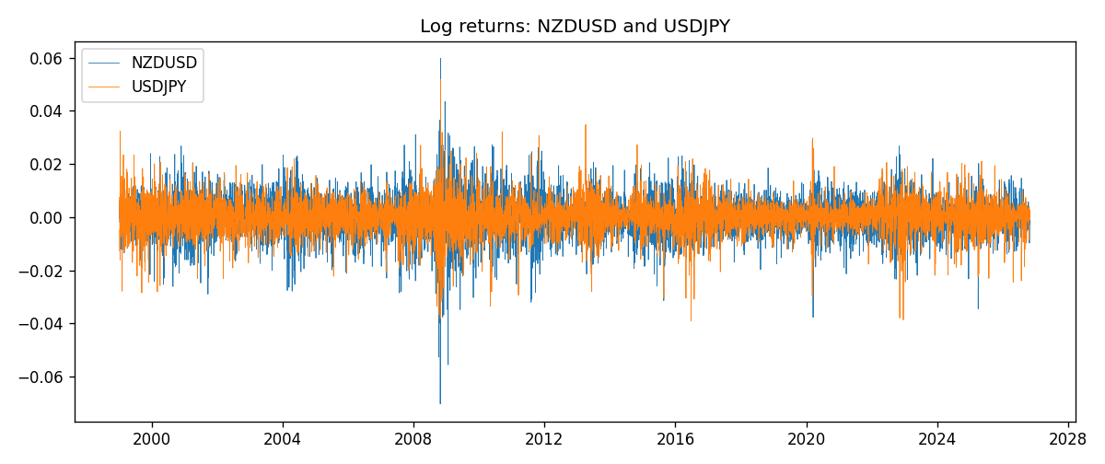

Data report
Matched rows are in the sibling Excel workbook named NZDUSD-USDJPY_Coint_D1.xlsx. Embedding all rows as a Word table is impractical; this file holds column summaries and the first and last 15 matched rows.
Column summaries
column | count | mean | std | min | 25% | 50% | 75% | max
NZDUSD_open | 7185 | 0.65641035 | 0.10820414 | 0.3913 | 0.59133 | 0.6684 | 0.72491 | 0.88218
USDJPY_open | 7185 | 113.80829 | 19.224285 | 75.693 | 104.39 | 110.98 | 120.695 | 163.824
NZDUSD_high | 7185 | 0.6603272 | 0.1086977 | 0.3961 | 0.59474 | 0.672 | 0.72936 | 0.88421
USDJPY_high | 7185 | 114.30556 | 19.28576 | 76.001 | 104.868 | 111.439 | 121.26 | 163.978
NZDUSD_low | 7185 | 0.65272421 | 0.10779902 | 0.3897 | 0.58806 | 0.66417 | 0.72098 | 0.87988
USDJPY_low | 7185 | 113.28523 | 19.152023 | 75.402 | 103.88 | 110.53 | 120.17 | 163.628
NZDUSD_close | 7185 | 0.65648647 | 0.10820164 | 0.3907 | 0.59157 | 0.6684 | 0.72502 | 0.8822
USDJPY_close | 7185 | 113.8211 | 19.239467 | 75.811 | 104.38 | 111.015 | 120.69 | 163.851
NZDUSD_tick_volume | 7185 | 68717.699 | 123140.61 | 16 | 5585 | 33899 | 58511 | 1127682
USDJPY_tick_volume | 7185 | 106344.18 | 179438.14 | 149 | 9948 | 53202 | 92889 | 1803508
NZDUSD_spread | 7185 | 30.280167 | 25.649381 | 0 | 9 | 17 | 40 | 80
USDJPY_spread | 7185 | 20.273626 | 17.623751 | 0 | 6 | 11 | 30 | 50
NZDUSD_real_volume | 7185 | 1.6703703e+10 | 8.4983725e+10 | 0 | 0 | 0 | 0 | 2.705649e+12
USDJPY_real_volume | 7185 | 3.4781051e+10 | 1.6093614e+11 | 0 | 0 | 0 | 0 | 3.8834203e+12
NZDUSD_log_price | 7185 | -0.43560726 | 0.17591902 | -0.93981528 | -0.52497526 | -0.40286848 | -0.32155604 | -0.12533649
USDJPY_log_price | 7185 | 4.7205361 | 0.16793459 | 4.3282434 | 4.6480381 | 4.7096653 | 4.7932253 | 5.0989575
NZDUSD_log_return | 7185 | 1.284e-05 | 0.0076404 | -0.07027433 | -0.00425236 | 0.00022967 | 0.00458145 | 0.05966839
USDJPY_log_return | 7185 | 4.789e-05 | 0.00620418 | -0.03908203 | -0.00320044 | 0.00011802 | 0.00340223 | 0.05184024
spread_e | 7185 | -0 | 0.14732415 | -0.34468042 | -0.0762912 | 5.44e-06 | 0.06930217 | 0.33849459
ecm_fitted | 7184 | 4.792e-05 | 0.00031457 | -0.00366613 | -0.0001215 | 3.063e-05 | 0.00019497 | 0.00377648
First 15 matched rows (selected columns)
time | NZDUSD_log_price | USDJPY_log_price | spread_e | NZDUSD_log_return | USDJPY_log_return
1999-01-05 | -0.62138481 | 4.7177843 | -0.087876827 | -0.0018597736 | -0.00017868311
1999-01-06 | -0.61933925 | 4.7253503 | -0.079373515 | 0.0020455609 | 0.0075660159
1999-01-07 | -0.61304294 | 4.7124988 | -0.089340063 | 0.0062963171 | -0.012851583
1999-01-08 | -0.6135969 | 4.7077268 | -0.094365885 | -0.00055396548 | -0.0047719894
1999-01-11 | -0.60330648 | 4.6915314 | -0.10584613 | 0.010290425 | -0.016195423
1999-01-12 | -0.60862223 | 4.7238417 | -0.075971498 | -0.0053157489 | 0.032310364
1999-01-13 | -0.61859645 | 4.731979 | -0.072404468 | -0.0099742238 | 0.0081373171
1999-01-14 | -0.6187821 | 4.731979 | -0.072489534 | -0.00018564931 | 0
1999-01-15 | -0.61952504 | 4.7375134 | -0.067295618 | -0.00074294208 | 0.0055343401
1999-01-18 | -0.62138481 | 4.737601 | -0.068060184 | -0.0018597736 | 8.7600193e-05
1999-01-19 | -0.61952504 | 4.731979 | -0.072829958 | 0.0018597736 | -0.0056219403
1999-01-20 | -0.61544567 | 4.726591 | -0.076348743 | 0.0040793678 | -0.0053879917
1999-01-21 | -0.61138288 | 4.7350574 | -0.066020725 | 0.0040627941 | 0.0084664056
1999-01-22 | -0.62343457 | 4.7410987 | -0.065501671 | -0.012051689 | 0.0060412564
1999-01-25 | -0.62698498 | 4.7337393 | -0.074487921 | -0.0035504102 | -0.0073594164
Last 15 matched rows (selected columns)
time | NZDUSD_log_price | USDJPY_log_price | spread_e | NZDUSD_log_return | USDJPY_log_return
2026-10-13 | -0.57755321 | 5.0645236 | 0.27894647 | 0.0047326165 | -0.0018932826
2026-10-14 | -0.58128385 | 5.0645994 | 0.27731285 | -0.0037306483 | 7.5800166e-05
2026-10-15 | -0.57652037 | 5.0627469 | 0.27764309 | 0.0047634855 | -0.0018524319
2026-10-16 | -0.57077027 | 5.0623672 | 0.27989808 | 0.0057501001 | -0.00037976126
2026-10-19 | -0.56887856 | 5.0658618 | 0.28425957 | 0.0018917133 | 0.0034946841
2026-10-20 | -0.56515862 | 5.0636072 | 0.28370942 | 0.0037199341 | -0.0022546642
2026-10-21 | -0.56206629 | 5.0632783 | 0.28479752 | 0.0030923331 | -0.00032883504
2026-10-22 | -0.56536981 | 5.0546841 | 0.27468954 | -0.0033035227 | -0.0085942669
2026-10-23 | -0.56227683 | 5.0550349 | 0.27645758 | 0.0030929853 | 0.00035080446
2026-10-26 | -0.56517622 | 5.0591588 | 0.27925293 | -0.0028993932 | 0.0041238746
2026-10-27 | -0.56544022 | 5.0619239 | 0.28189713 | -0.00026399852 | 0.0027651658
2026-10-28 | -0.57516861 | 5.0609671 | 0.27648269 | -0.0097283914 | -0.00095679538
2026-10-29 | -0.5745467 | 5.0605867 | 0.27638721 | 0.00062190714 | -0.00038043789
2026-10-30 | -0.57435132 | 5.059527 | 0.27541709 | 0.00019537668 | -0.0010596481
2026-11-02 | -0.57694762 | 5.0621709 | 0.27687129 | -0.0025962955 | 0.0026438521

